# System Overview Use Case

This session provides a brief overview of all project feature.

User who interact directly with the system can be divided into 3 kinds of actors as follows:

|  |  |  |
| --- | --- | --- |
| **No.** | **Actor** | **Description** |
| **1** | Guest | Anonymous visitors |
| **2** | Member | Guest who logged in |
| **3** | Site owner | Member who already has had at least 1 product catalogue sites. |
| **4** | Admin | User who has the right of administration: manage all activities happen in the system. |

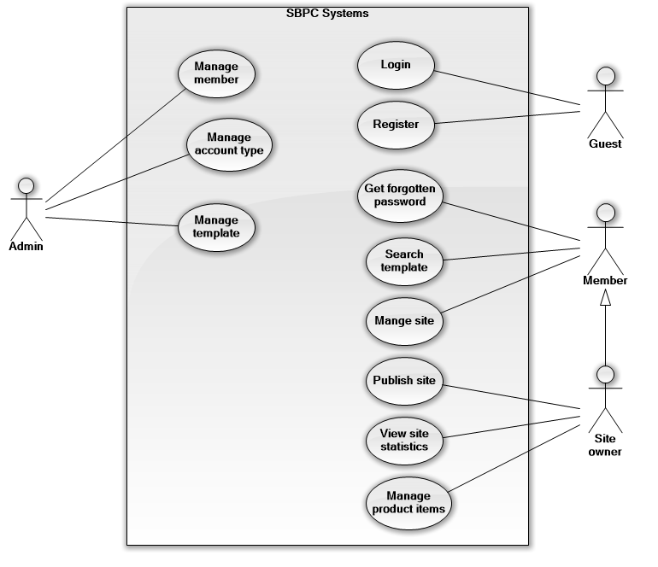

# List of Use Case

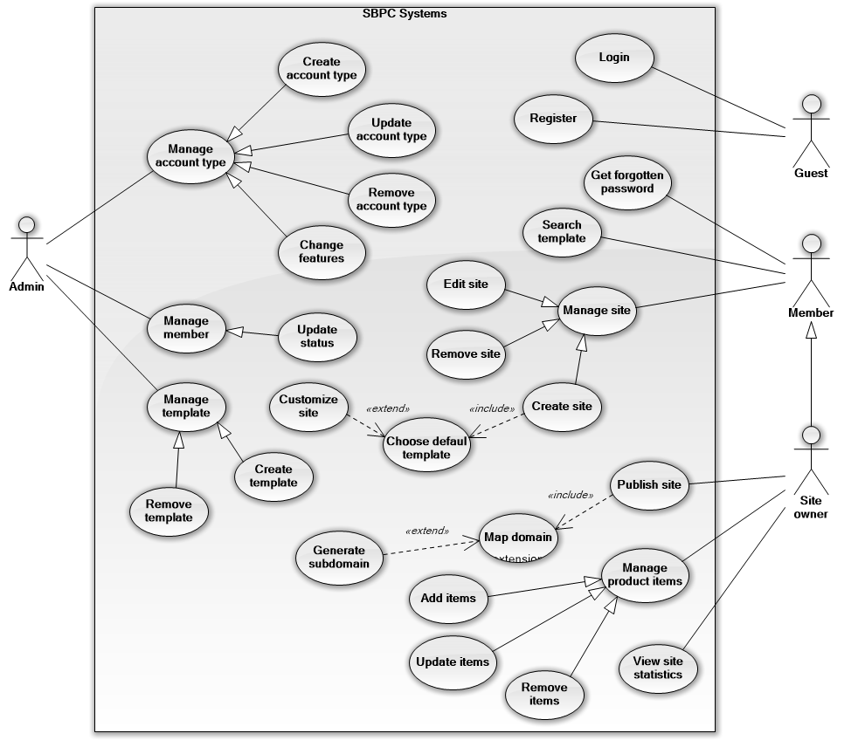

## <Guest> Register

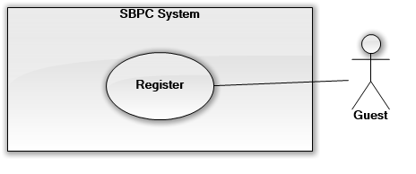

|  |  |  |  |
| --- | --- | --- | --- |
| **USECASE – SBPC** | | | |
| **Use Case No.** |  | **Use Case Version** | 1.0 |
| **Use Case Name** | Register | | |
| **Author** | ThangPV | | |
| **Date** | 19/01/2015 | **Priority** | Normal |
| **Actor:**   * Guest   **Summary:**   * This use case allows guest to become a system member by registering.   **Goal:**   * Guest can log in the system by registered account.   **Triggers:**   * Click “Register” button   **Preconditions:**  **Post Conditions:**   * **Success:** Show success message. * **Fail:** Show message error   **Main Success Scenario:**   |  |  |  | | --- | --- | --- | | Step | Actor Action | System Response | | 1 | Guest click on “Register” link.  [Alternative 1] | Display “Register” page with text box for quest enter necessary information | | 2 | Guest input all required fields.  Click “summit” button. | Validate data [Exception 1]  System create new account for Guest  Show message: “Register successfully”  [Exception 2] |   **Alternative Scenario:**   |  |  |  | | --- | --- | --- | | No | Actor Action | System Response | | 1 | Click “Cancel” button | Discard all input information.  Redirect to “Home” page |   **Exceptions:**   |  |  |  | | --- | --- | --- | | No | Actor Action | System Response | | 1 | Invalid data | Do not insert to database  Show error message | | 2 | Connect to database fail | Show message “Database connection error, refresh your browser”. |   **Relationships:** N/A  **Business Rules:** | | | |

## <Member> Get Forgotten Password

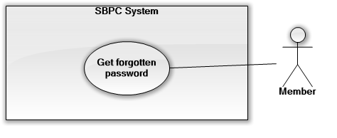

|  |  |  |  |
| --- | --- | --- | --- |
| **USECASE – SBPC** | | | |
| **Use Case No.** | SBPC | **Use Case Version** | 1.0 |
| **Use Case Name** | Get Forgotten Password | | |
| **Author** | ThangPV | | |
| **Date** | 19/01/2015 | **Priority** | Normal |
| **Actor:**   * Member   **Summary:**   * Member can find back his forgot password.   **Goal:**   * Member receives current password via registered email.   **Triggers:**   * Member clicks on “forget password” link.   **Preconditions:**   * Member has his account’s username.   **Post Conditions:**   * **Success:** Show success message, send email which include password information. * **Fail:** N/A   **Main Success Scenario:**   |  |  |  | | --- | --- | --- | | Step | Actor Action | System Response | | 1 | User clicks on “Forget password” link. | Redirect to “Forget password” page which include text box username. | | 2 | User entered username of account which you intent to take back password.  Click “summit” button | Validate entered data.  Search for password which math with entered email. Then send password via that email.  Show notification message for success.  [Exception 1] |   **Alternative Scenario:** N/A  **Exceptions:**   |  |  |  | | --- | --- | --- | | No | Actor Action | System Response | | 1 | Cannot send email | Show message “Error, cannot send email”. |   **Relationships:** N/A  **Business Rules:**   * User must fill valid username. * User received an email which include information of current password. | | | |

## <Member> Search template

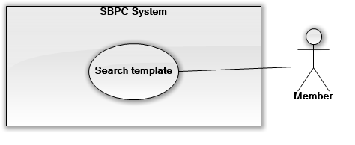

|  |  |  |  |
| --- | --- | --- | --- |
| **USECASE – SBPC** | | | |
| **Use Case No.** | SBPC | **Use Case Version** | 1.0 |
| **Use Case Name** | Search template | | |
| **Author** | ThangPV | | |
| **Date** | 19/01/2015 | **Priority** | Normal |
| **Actor:**   * Member   **Summary:**   * Member can search template from all available templates.   **Goal:**   * Member view a list of all suitable template.   **Triggers:**   * Member clicks on “Search” button.   **Preconditions:**   * N/A   **Post Conditions:**   * **Success:** Result templates which suitable characteristics are shown. * **Fail:**   **Main Success Scenario:**   |  |  |  | | --- | --- | --- | | Step | Actor Action | System Response | | 1 | Choose some site characteristic:   * Color * View properties | Retrieve suitable template from database  Show list of templates  [Exception 1] |   **Alternative Scenario:** N/A  **Exceptions:**   |  |  |  | | --- | --- | --- | | No | Actor Action | System Response | | 1 | Connect to database fail | Show message “Error, cannot connect to database”. |   **Relationships:** N/A  **Business Rules:**   * Result template can be chosen to create product catalogue site or customize | | | |

## <Admin> Create account type

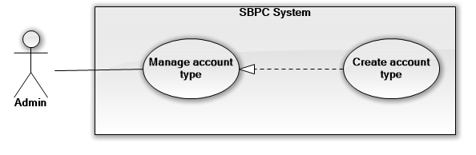

|  |  |  |  |
| --- | --- | --- | --- |
| **USECASE – SBPC** | | | |
| **Use Case No.** | SBPC | **Use Case Version** | 1.0 |
| **Use Case Name** | Manage account type | | |
| **Author** | ThangPV | | |
| **Date** | 19/01/2015 | **Priority** | Normal |
| **Actor:**   * Admin   **Summary:**   * Admin can create new account type.   **Goal:**   * New account type are created and apply.   **Triggers:**   * Admin clicks on “Add new type” button.   **Preconditions:**   * Admin is being in “Admin dashboard” page.   **Post Conditions:**   * **Success:** New account type is inserted into system. * **Fail:**   **Main Success Scenario:**   |  |  |  | | --- | --- | --- | | Step | Actor Action | System Response | | 1 | Click “Add new type” button | Redirect to “Add new type” page, included text box for required information. | | 2 | Entered all required information of account type  Click “Submit” button.  [Alternative 1] | Validate entered field  [Exception 1]  Insert new account type into database  Show notification message for insert successfully |   **Alternative Scenario:** N/A   |  |  |  | | --- | --- | --- | | No | Actor Action | System Response | | 1 | Click “Reset” button. | Reset all fields to blank. |   **Exceptions:**   |  |  |  | | --- | --- | --- | | No | Actor Action | System Response | | 1 | Enter invalid or not enter required fields | Show message for invalid fields. |   **Relationships:** N/A  **Business Rules:**   * New account type is created form inputted information with id is automatically generated by the system. | | | |

## <Admin> Update account type

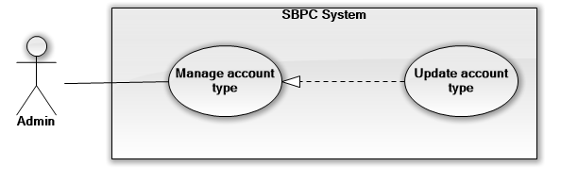

|  |  |  |  |
| --- | --- | --- | --- |
| **USECASE – SBPC** | | | |
| **Use Case No.** | SBPC | **Use Case Version** | 1.0 |
| **Use Case Name** | Update account type | | |
| **Author** | ThangPV | | |
| **Date** | 19/01/2015 | **Priority** | Normal |
| **Actor:**   * Admin   **Summary:**   * Admin can update account type information.   **Goal:**   * Changed account type information are updated.   **Triggers:**   * Admin clicks on “Edit” button.   **Preconditions:**   * Admin is being in “Admin dashboard” page. * At least one account type is available.   **Post Conditions:**   * **Success:** Changed account type information are updated into database. * **Fail:**   **Main Success Scenario:**   |  |  |  | | --- | --- | --- | | Step | Actor Action | System Response | | 1 | Click “Edit” icon that are shown at “Action” column. | Show “Account type detail” page which include all of account type’s information and shown as text box. | | 2 | Enter new information that user need to change or update.  Click “Save” button  [Alternative 1] | Validate entered field  [Exception 1]  Update changed account type information into database  Show notification message for update successfully |   **Alternative Scenario:** N/A   |  |  |  | | --- | --- | --- | | No | Actor Action | System Response | | 1 | Click “Cancel” button. | Discard and redirect to previous page |   **Exceptions:**   |  |  |  | | --- | --- | --- | | No | Actor Action | System Response | | 1 | Enter invalid or not enter required fields | Show message for invalid fields. |   **Relationships:** N/A  **Business Rules:**   * All account type information are available for updated or changed, except its id. * Account type information are updated base on its ID. * If user don’t click “Save” button, all new entered information are discard. | | | |

## <Admin> Remove account type

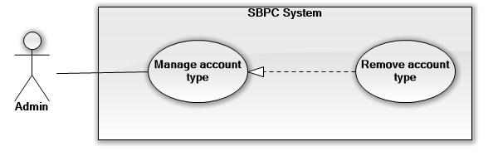

|  |  |  |  |
| --- | --- | --- | --- |
| **USECASE – SBPC** | | | |
| **Use Case No.** | SBPC | **Use Case Version** | 1.0 |
| **Use Case Name** | Remove account type | | |
| **Author** | ThangPV | | |
| **Date** | 19/01/2015 | **Priority** | Normal |
| **Actor:**   * Admin   **Summary:**   * Admin can remove an account type.   **Goal:**   * Changed account type information are updated.   **Triggers:**   * Admin clicks on “Delete” button.   **Preconditions:**   * Admin is being in “Admin dashboard” page. * At least one account type is available.   **Post Conditions:**   * **Success:** Account type will be deleted permanent from database. * **Fail:**   **Main Success Scenario:**   |  |  |  | | --- | --- | --- | | Step | Actor Action | System Response | | 1 | Click “Delete” icon that are shown at “Action” column. | Show confirmation popup. | | 2 | Click “Yes” button.  [Alternative 1] | Delete account type from database  [Exception 1]  Show notification message for delete successfully |   **Alternative Scenario:** N/A   |  |  |  | | --- | --- | --- | | No | Actor Action | System Response | | 1 | Click “No” button. | Discard and redirect to previous page |   **Exceptions:**   |  |  |  | | --- | --- | --- | | No | Actor Action | System Response | | 1 | Connect to system database fail | Show message “Connect fail, refresh your brower” |   **Relationships:** N/A  **Business Rules:**   * Account type information is deleted base on its ID. * If user don’t click “Yes” button, all new entered information are discard. | | | |